PRESS RELEASE

Macbeth consolidates regional leadership position with
Insurance Services Surrey Ltd acquisition
Reading, 06/02/2025: Macbeth has completed the purchase of Surrey-based insurance broker, Insurance Services Surrey Ltd (ISS), further consolidating the Top 100 business as a leading regional broker.

Macbeth’s purchase takes its Group GWP income from £41m to £45m and sees the Reading-HQ based team grow to 73, including the former owners of ISS; Peter Sambrook, John Goodson & Rob Tipping who, together with the wider ISS team will remain with Macbeth.
“We’re thrilled to welcome Peter, John, Rob and the wider team to the Macbeth family,” says Paul Macbeth, CEO. We have known John for several years and as soon as we met Peter and Rob, we knew this was a fantastic opportunity to work together.
“We don’t actively look to acquire but in ISS, we recognised a business that, like Macbeth, puts its people first and is totally focused on providing their clients with an exceptional service. We’ll continue to consider selective acquisitions in the future, if the fit’s right from both that cultural and geographical point of view. This isn’t about being the biggest. It’s about being the best we can be, and having some fun along the way.
Peter Sambrook, Managing Director at ISS adds, “This was never about selling to the highest bidder for us, but finding the right fit. Paul and Ben share the same approach as us; putting service, staff and their clients first, and we are looking forward to this next chapter working with them.”
Reading law firm Field Seymour Parkes advised Macbeth on the acquisition, with accountancy and advisory firm White Hart Associates, also acting for the business.

About Macbeth
Macbeth is one of the fastest growing insurance and financial businesses in the Thames Valley with a brand and passion for delivering independent advice backed by a truly outstanding, client-focused service. We are a Chartered, award-winning company, with a professional culture that underpins everything that we do.
The company is actively committed to supporting local business partners, charities and our community, including Alexander Devine Childrens’ Hospice, RAMS Rugby, Reading Rotary Club, Marlow Rotary Club, Henley Festival, Calcot Golf Club, Ethical Reading and Reading Rascals Junior Triathlon Club.

Images
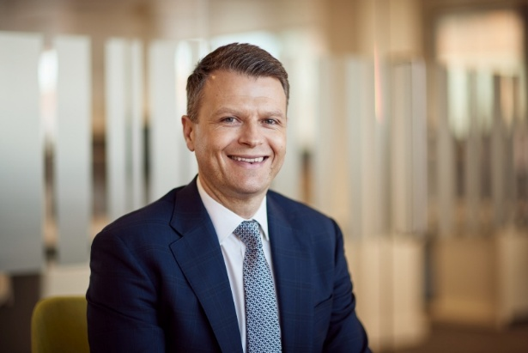
Paul Macbeth ACII, CEO

Macbeth logos
